**PROYEK ALGORITMA DAN PEMROGRAMAN-01**

***SISTEM RESERVASI BIOSKOP***



Disusun oleh :

Kelompok : 02

Nama Anggota : Dita Tessa Parastika 1206201536

Dwinanri Egyna 1206201593

Erdi Nindito Rumono 1206201523

Dosen : Ir. Ratna

Gde

**DEPARTEMEN TEKNIK ELEKTRO**

**FAKULTAS TEKNIK UNIVERSITAS INDONESIA**

**DEPOK 2014**

1. **Algoritma pemecahan masalah dalam bentuk pseudocode dan flowchart**

* **Flowchart**

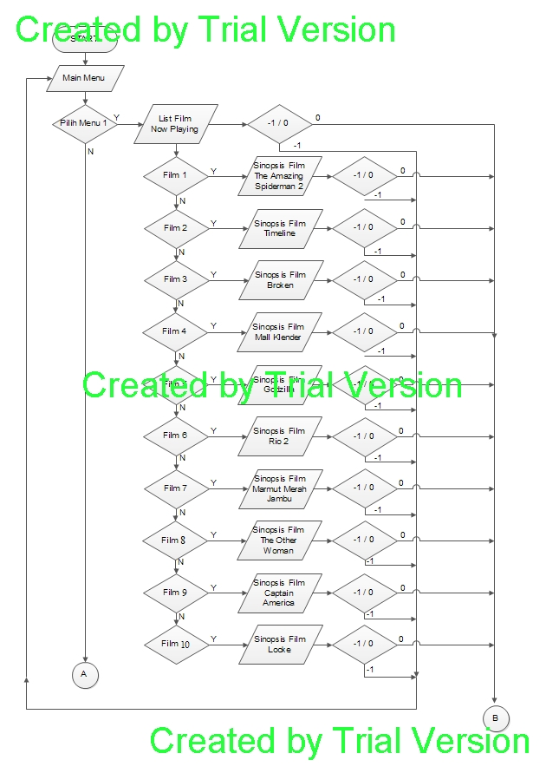

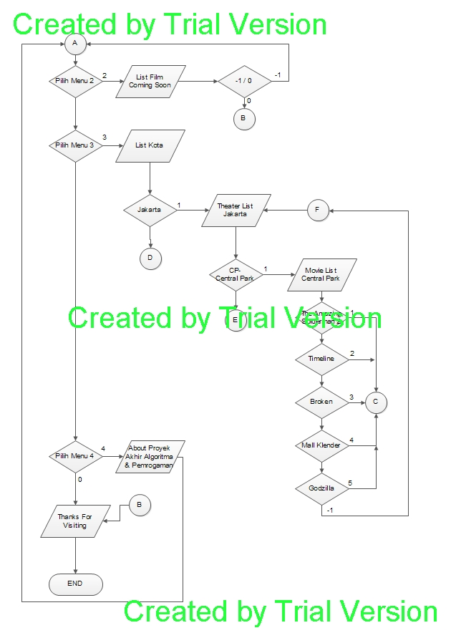

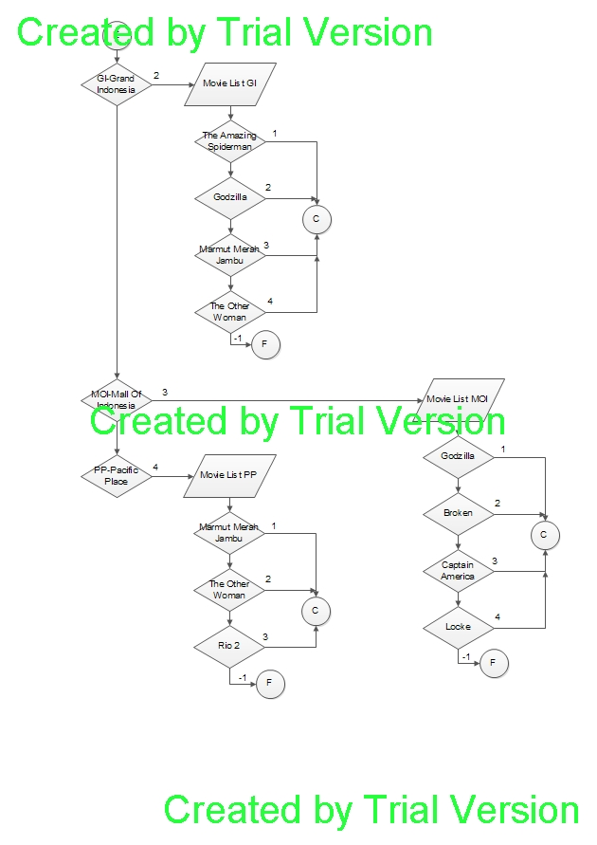

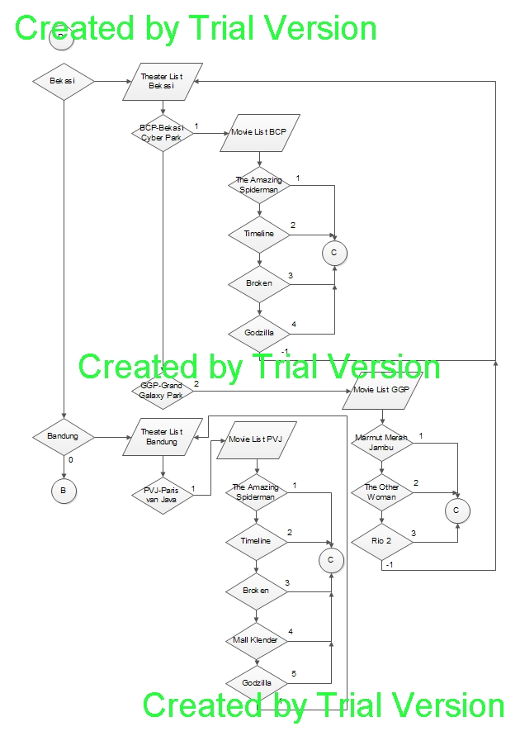

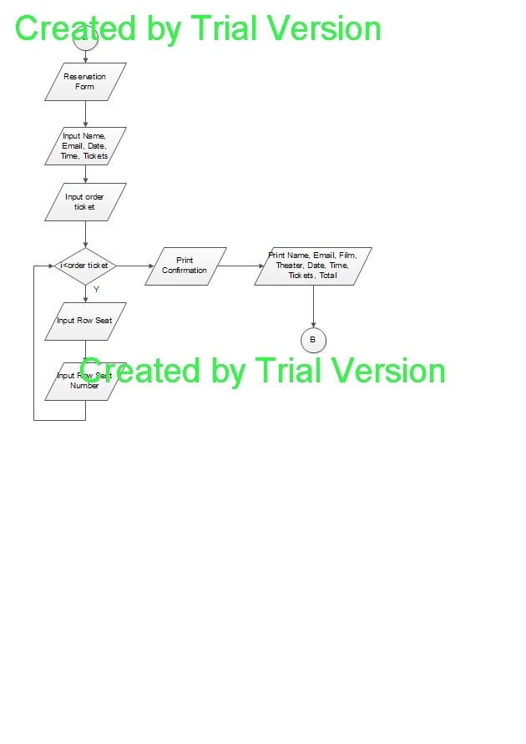

* **Pseudocode**

Initialize program

Display menu awal

Switch menu

Case 1: display now playing film

Switch film

Case 1: display sinopsis The Amazing Spiderman 2

Case 2: display sinopsis Timeline

Case 3: display sinopsis Broken

Case 4: display sinopsis Mall Klender

Case 5: display sinopsis Godzilla

Case 6: display sinopsis Rio

Case 7: display sinopsis Marmut Merah Jambu

Case 8: display sinopsis The Other Woman

Case 9: display sinopsis Captain America

Case 10: display sinopsis Locke

Case 2: display coming soon film

Case 3: display kota letak bioskop

Switch city

Case 1: display nama bioskop di Jakarta

Switch theater

Case 1: display movie list Central Park

Switch Film

Case 1: display Reservation Form The Amazing Spiderman

Prompt name Get name

Prompt email Get email

Prompt tanggal Get tanggal

Prompt waktu Get waktu

Prompt tiket Get jumlah

Total = 40000*jumlah

Display Confirmation

Display name, email, tanggal, waktu,

Case 2: display Reservation Form Timeline

Prompt name Get name

Prompt email Get email

Prompt tanggal Get tanggal

Prompt waktu Get waktu

Prompt tiket Get jumlah

Total = 40000*jumlah

Display Confirmation

Display name, email, tanggal, waktu,

Case 3: display Reservation Form Broken

Prompt name Get name

Prompt email Get email

Prompt tanggal Get tanggal

Prompt waktu Get waktu

Prompt tiket Get jumlah

Total = 40000*jumlah

Display Confirmation

Display name, email, tanggal, waktu,

Case 4: display Reservation Form Mall Klender

Prompt name Get name

Prompt email Get email

Prompt tanggal Get tanggal

Prompt waktu Get waktu

Prompt tiket Get jumlah

Total = 40000*jumlah

Display Confirmation

Display name, email, tanggal, waktu,

Case 5: display Reservation Form Godzilla

Prompt name Get name

Prompt email Get email

Prompt tanggal Get tanggal

Prompt waktu Get waktu

Prompt tiket Get jumlah

Total = 40000*jumlah

Display Confirmation

Display name, email, tanggal, waktu,

Case 2: display movie list Grand Indonesia

Switch Film

Case 1: display Reservation Form The Amazing Spiderman

Prompt name Get name

Prompt email Get email

Prompt tanggal Get tanggal

Prompt waktu Get waktu

Prompt tiket Get jumlah

Total = 50000*jumlah

Display Confirmation

Display name, email, tanggal, waktu,

Case 2: display Reservation Form Godzilla

Prompt name Get name

Prompt email Get email

Prompt tanggal Get tanggal

Prompt waktu Get waktu

Prompt tiket Get jumlah

Total = 50000*jumlah

Display Confirmation

Display name, email, tanggal, waktu,

Case 3: display Reservation Form Marmut Merah Jambu

Prompt name Get name

Prompt email Get email

Prompt tanggal Get tanggal

Prompt waktu Get waktu

Prompt tiket Get jumlah

Total = 50000*jumlah

Display Confirmation

Display name, email, tanggal, waktu,

Case 4: display Reservation Form The Other Woman

Prompt name Get name

Prompt email Get email

Prompt tanggal Get tanggal

Prompt waktu Get waktu

Prompt tiket Get jumlah

Total = 50000*jumlah

Display Confirmation

Display name, email, tanggal, waktu,

Case 3: display movie list Mall of Indonesia

Switch Film

Case 1: display Reservation Form Godzilla

Prompt name Get name

Prompt email Get email

Prompt tanggal Get tanggal

Prompt waktu Get waktu

Prompt tiket Get jumlah

Total = 40000*jumlah

Display Confirmation

Display name, email, tanggal, waktu,

Case 2: display Reservation Form Broken

Prompt name Get name

Prompt email Get email

Prompt tanggal Get tanggal

Prompt waktu Get waktu

Prompt tiket Get jumlah

Total = 40000*jumlah

Display Confirmation

Display name, email, tanggal, waktu,

Case 3: display Reservation Form Captain America

Prompt name Get name

Prompt email Get email

Prompt tanggal Get tanggal

Prompt waktu Get waktu

Prompt tiket Get jumlah

Total = 40000*jumlah

Display Confirmation

Display name, email, tanggal, waktu,

Case 4: display Reservation Form Locke

Prompt name Get name

Prompt email Get email

Prompt tanggal Get tanggal

Prompt waktu Get waktu

Prompt tiket Get jumlah

Total = 40000*jumlah

Display Confirmation

Display name, email, tanggal, waktu,

Case 4: display movie list Pacific Place

Switch Film

Case 1: display Reservation Form Marmut Merah Jambu

Prompt name Get name

Prompt email Get email

Prompt tanggal Get tanggal

Prompt waktu Get waktu

Prompt tiket Get jumlah

Total = 50000*jumlah

Display Confirmation

Display name, email, tanggal, waktu,

Case 2: display Reservation Form The Other Woman

Prompt name Get name

Prompt email Get email

Prompt tanggal Get tanggal

Prompt waktu Get waktu

Prompt tiket Get jumlah

Total = 50000*jumlah

Display Confirmation

Display name, email, tanggal, waktu,

Case 3: display Reservation Form Rio 2

Prompt name Get name

Prompt email Get email

Prompt tanggal Get tanggal

Prompt waktu Get waktu

Prompt tiket Get jumlah

Total = 50000*jumlah

Display Confirmation

Display name, email, tanggal, waktu,

Case 2: display nama bioskop di Bekasi

Switch theater

Case 1: display movie list Bekasi Cyber Park

Switch Film

Case 1: display Reservation Form The Amazing Spiderman

Prompt name Get name

Prompt email Get email

Prompt tanggal Get tanggal

Prompt waktu Get waktu

Prompt tiket Get jumlah

Total = 40000*jumlah

Display Confirmation

Display name, email, tanggal, waktu,

Case 2: display Reservation Form Timeline

Prompt name Get name

Prompt email Get email

Prompt tanggal Get tanggal

Prompt waktu Get waktu

Prompt tiket Get jumlah

Total = 40000*jumlah

Display Confirmation

Display name, email, tanggal, waktu,

Case 3: display Reservation Form Broken

Prompt name Get name

Prompt email Get email

Prompt tanggal Get tanggal

Prompt waktu Get waktu

Prompt tiket Get jumlah

Total = 40000*jumlah

Display Confirmation

Display name, email, tanggal, waktu,

Case 4: display Reservation Form Godzilla

Prompt name Get name

Prompt email Get email

Prompt tanggal Get tanggal

Prompt waktu Get waktu

Prompt tiket Get jumlah

Total = 40000*jumlah

Display Confirmation

Display name, email, tanggal, waktu,

Case 2: display movie list Grand Galaxy Park

Switch Film

Case 1: display Reservation Form Marmut Merah Jambu

Prompt name Get name

Prompt email Get email

Prompt tanggal Get tanggal

Prompt waktu Get waktu

Prompt tiket Get jumlah

Total = 45000*jumlah

Display Confirmation

Display name, email, tanggal, waktu,

Case 2: display Reservation Form The Othet Woman

Prompt name Get name

Prompt email Get email

Prompt tanggal Get tanggal

Prompt waktu Get waktu

Prompt tiket Get jumlah

Total = 45000*jumlah

Display Confirmation

Display name, email, tanggal, waktu,

Case 3: display Reservation Form Rio 2

Prompt name Get name

Prompt email Get email

Prompt tanggal Get tanggal

Prompt waktu Get waktu

Prompt tiket Get jumlah

Total = 45000*jumlah

Display Confirmation

Display name, email, tanggal, waktu,

Case 3: display nama bioskop di Bandung

Switch theater

Case 1: display movie list Paris Van Java

Switch Film

Case 1: display Reservation Form The Amazing Spiderman

Prompt name Get name

Prompt email Get email

Prompt tanggal Get tanggal

Prompt waktu Get waktu

Prompt tiket Get jumlah

Total = 50000*jumlah

Display Confirmation

Display name, email, tanggal, waktu,

Case 2: display Reservation Form Timeline

Prompt name Get name

Prompt email Get email

Prompt tanggal Get tanggal

Prompt waktu Get waktu

Prompt tiket Get jumlah

Total = 50000*jumlah

Display Confirmation

Display name, email, tanggal, waktu,

Case 3: display Reservation Form Broken

Prompt name Get name

Prompt email Get email

Prompt tanggal Get tanggal

Prompt waktu Get waktu

Prompt tiket Get jumlah

Total = 50000*jumlah

Display Confirmation

Display name, email, tanggal, waktu,

Case 4: display Reservation Form Mall Klender

Prompt name Get name

Prompt email Get email

Prompt tanggal Get tanggal

Prompt waktu Get waktu

Prompt tiket Get jumlah

Total = 50000*jumlah

Display Confirmation

Display name, email, tanggal, waktu,

Case 5: display Reservation Form Godzilla

Prompt name Get name

Prompt email Get email

Prompt tanggal Get tanggal

Prompt waktu Get waktu

Prompt tiket Get jumlah

Total = 50000*jumlah

Display Confirmation

Display name, email, tanggal, waktu,

Case 4: display about the program

Case 0: end program

1. **Penjelasan masing-masing modul dalam program bersesuaian dengan algoritma yang digunakan**

Dalam program yang kami buat terdapat modul array dan juga modular programming. Array kami gunakan dalam program ini diantaranya untuk mengisi nama kota letak bioskop, nama bioskop tiap kota, dan juga nama film tiap bioskop, selain itu array juga kami gunakan dalam menggambarkan tempat duduk yang kosong dan akan terisi, dan juga waktu pemutaran film dalam bioskop-bioskop. Array kami gunakan karena data yang ingin disimpan memiliki kesamaan tipe data dan jumlah data yang disimpan statis atau tidak akan bertambah.

Terdapat 15 array dengan tipe data char, yaitu data yang disimpan berupa karakter digunakan untuk menyimpan data kota, nama bioskop tiap kota, nama film tiap bioskop, dan juga list now playing film & coming soon film.

Terdapat 9 array dengan tipe data float, yaitu data yang disimpan berupa bilangan berkoma. Data yang disimpan dalam array ini adalah waktu pemutaran film, menggunakan tipe data float karena pemisah waktu menggunakan titik sehingga jam bertindak sebagai bilangan >1 dan menit bertindak sebagai bilangan 1>menit>0.

Modular programming kami gunakan untuk menggambarkan sub menu – sub menu yang terdapat dalam program. Main menu yang berupa tampilan menu utama terdapat fungsi switch dengan 4 pilihan, dimana tiap pilihan dalam case switch tersebut akan masuk ke dalam modular programming sub menu. Modular programming kami gunakan karena apabila terjadi kesalahan lebih mudah untuk mengidentifikasi letak kesalahan, selain itu apabila fungsi modular programming ingin diedit maka proses pengeditannya akan lebih mudah.

Terdapat 21 modular programming dengan inisialisasi integer, dimana modular programming ini akan mengembalikan data berupa integer. Modular programming ini merupakan bentuk tiap case dari switch yang terdapat dalam program. Contohnya untuk melihat sinopsis dari film, bioskop yang terletak di tiap kota, list film di tiap bioskop. Selain itu terdapat 2 void modular programming yang digunakan untuk menggambarkan kondisi seat dalam bioskop.

1. ***Screen capture* dari program yang dijalankan untuk tiap menu dan kondisi**

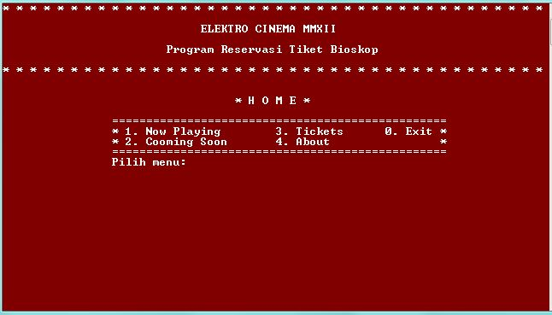

Menu Awal Program

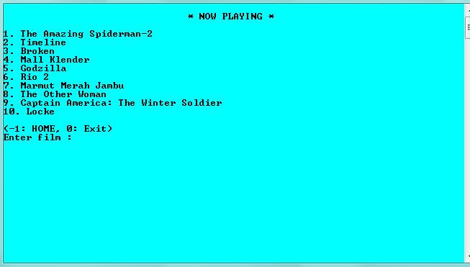

Apabila pada menu awal kita mengetik 1 maka akan masuk ke now playing menu

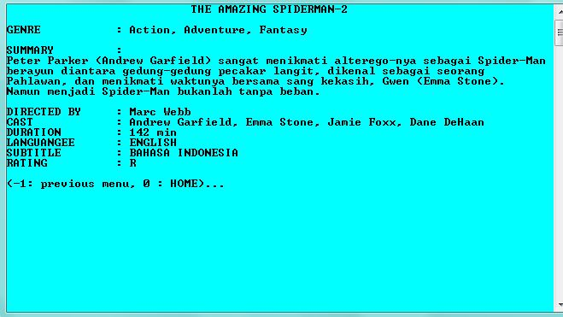

Dengan mengetikkan kode film pada menu now playing, akan tampak detail film

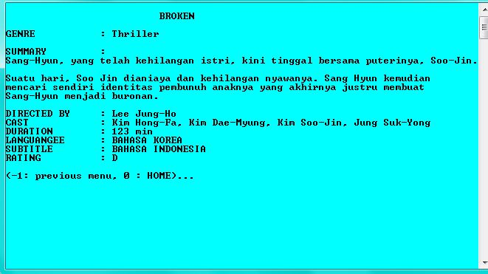

Contoh sinopsis/detail film

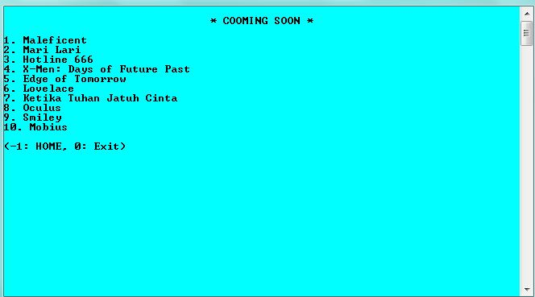

Jika pada menu awal mengetikkan 2, maka akan masuk ke list coming soon film

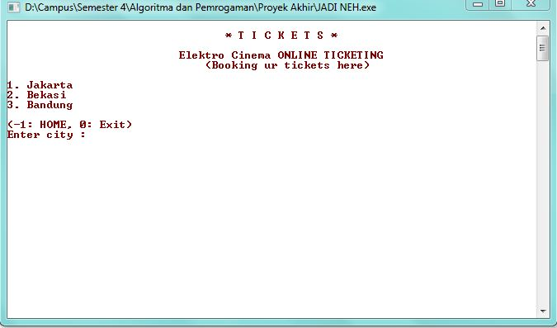

Jika pada menu awal mengetikkan 3, maka akan masuk ke reservasi tiket dengan tampilan awal memilih kota menonton

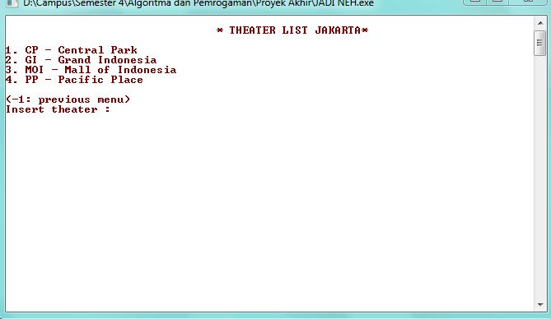

Tampilan jika memilih kota Jakarta

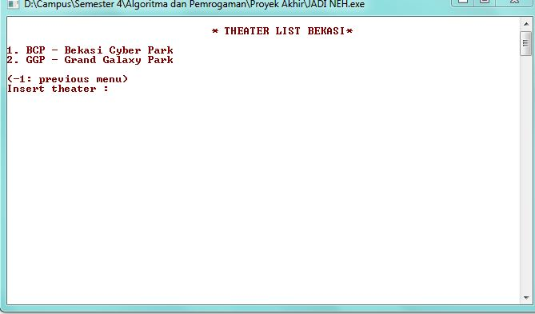

Tampilan jika memilih kota Bekasi

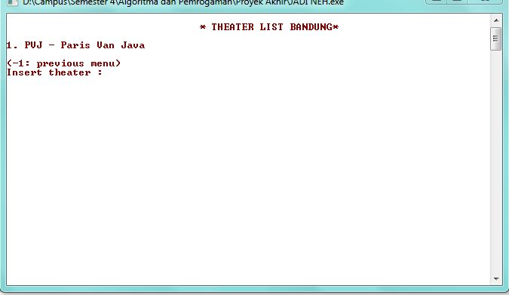

Tampilan jika memilih kota Bandung

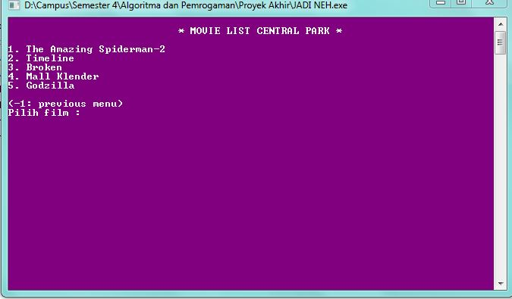

List Film pada Central Park Theater-Jakarta

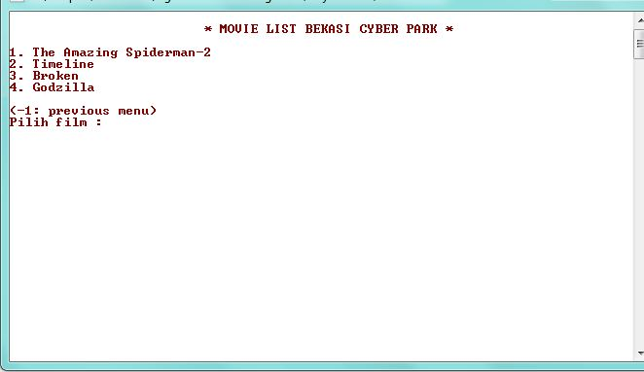

List film pada Bekasi Cyber Park Theater-Bekasi

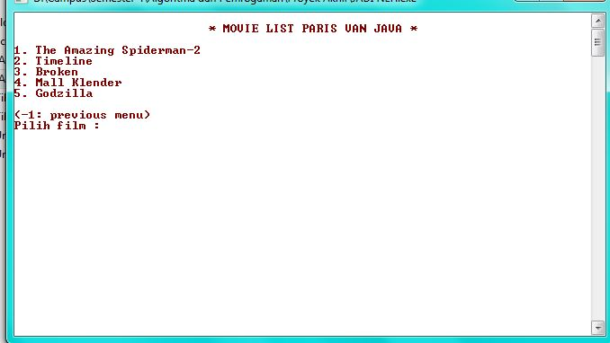

List film pada Paris Van Java Theater-Bandung

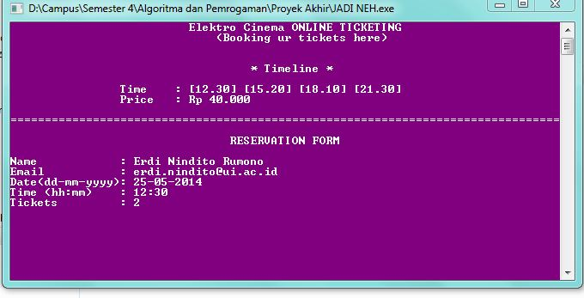

Reservation Form setelah memilih film pada bioskop di kota tertentu

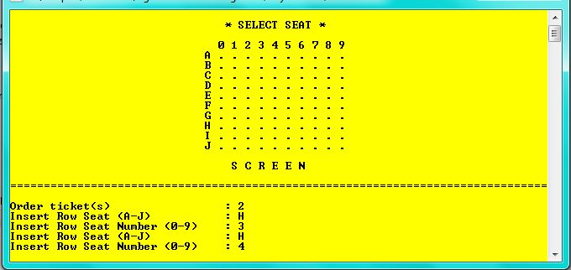

Tampilan layout Seat dan proses pemilihan seat

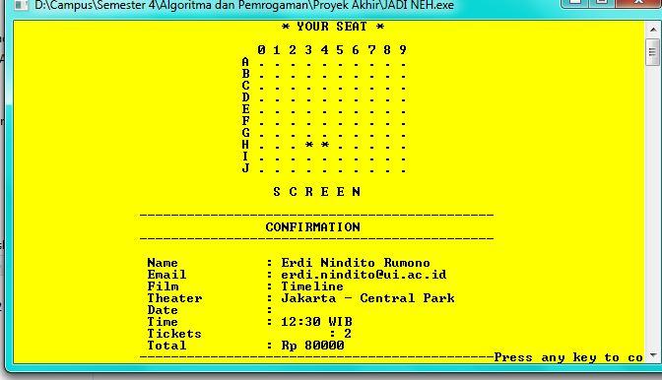

Konfirmasi atas pemesanan dan letak seat yang dipesan

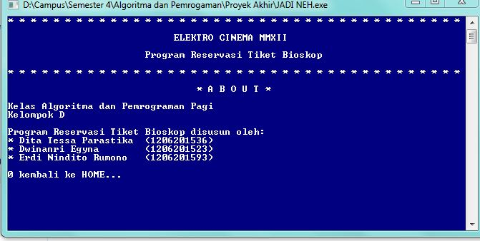

Menu About, jika memilih 4 dalam menu awal

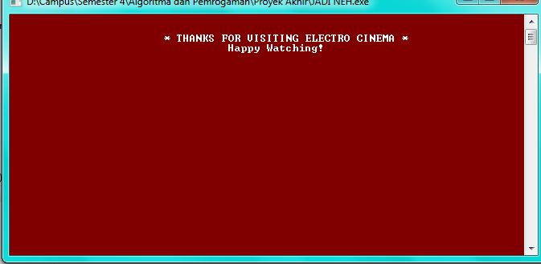

Tampilan Layar sebelum exit

1. **Listing progran**

#include <stdio.h>

#include <stdlib.h>

#include <string.h>

//fungsi modular

int submenu (int pilih);

int koleksi(int film);

int koleksics(int filmcs);

int tickets();

int duduk (int n);

int theaterjkt(int theater);

int theaterbks(int theater);

int theaterbdg(int theater);

int filmjkt(int theater);

int filmbks(int theater);

int filmbdg(int theater);

int filmlist_CP(int film);

int filmlist_GI(int film);

int filmlist_MOI(int film);

int filmlist_PP(int film);

int filmlist_BCP(int film);

int filmlist_GGP(int film);

int filmlist_PVJ(int film);

int booking(int film);

int sinopsis (int film);

int sinopsiscs(int filmcs);

char filmnp[10][50]={"The Amazing Spiderman-2", "Timeline", "Broken", "Mall Klender", "Godzilla", "Rio 2", "Marmut Merah Jambu", "The Other Woman", "Captain America: The Winter Soldier", "Locke"};

char filmcs[10][50]={"Maleficent", "Mari Lari", "Hotline 666", "X-Men: Days of Future Past", "Edge of Tomorrow", "Lovelace", "Ketika Tuhan Jatuh Cinta", "Oculus", "Smiley", "Mobius"};

char kota[50][50]={"Jakarta", "Bekasi", "Bandung"};

char theater_jkt[50][50]={"CP - Central Park", "GI - Grand Indonesia", "MOI - Mall of Indonesia", "PP - Pacific Place"};

char theater_bks[50][50]={"BCP - Bekasi Cyber Park", "GGP - Grand Galaxy Park"};

char theater_bdg[50][50]={"PVJ - Paris Van Java"};

//list jadwal tayang film

float time_Spi[5] = {13.00, 15.30, 18.00, 20.30, 21.00};

float time_Timeline[5] = {12.30, 15.20, 18.10, 21.30};

float time_Broken[5] = {12.30, 13.00, 15.00, 17.00, 20.30};

float time_MK[5] = {14.30, 16.30, 19.30};

float time_Godz[5] = {18.10, 20.45, 21.30};

float time_Rio[5] = {12.45, 14.55, 19.15, 21.25};

float time_Marmut[5] = {16.15, 17.45, 20.55};

float time_Woman[5] = {12.30, 15.20, 18.10, 21.30};

float time_Captain[5] = {12.30, 13.00, 15.00, 17.00, 20.30};

float time_Locke[5] = {18.30, 19.45, 21.30};

//list film theater di jakarta

char filmnp_CP[10][50]={"The Amazing Spiderman-2", "Timeline", "Broken", "Mall Klender", "Godzilla"};

char filmnp_GI[10][50]={"The Amazing Spiderman-2", "Godzilla", "Marmut Merah Jambu", "The Other Woman"};

char filmnp_MOI[10][50]={"Godzilla", "Broken", "Captain America: The Winter Soldier", "Locke"};

char filmnp_PP[10][50]={"Marmut Merah Jambu", "The Other Woman", "Rio 2"};

//list film theater di bekasi

char filmnp_BCP[10][50]={"The Amazing Spiderman-2", "Timeline", "Broken", "Godzilla"};

char filmnp_GGP[10][50]={"Marmut Merah Jambu", "The Other Woman", "Rio 2"};

//list film theater di bandung

char filmnp_PVJ[10][50]={"The Amazing Spiderman-2", "Godzilla", "Marmut Merah Jambu", "Captain America: The Winter Soldier", "Locke"};

char seatBuilding[5][10];

char header[500]={"* * * * * * * * * * * * * * * * * * * * * * * * * * * * * * * * * * * * * * * * \n\t\t\t ELEKTRO CINEMA MMXII\n\n\t\t\tProgram Reservasi Tiket Bioskop\n\n* * * * * * * * * * * * * * * * * * * * * * * * * * * * * * * * * * * * * * * *\n"};

char footer[100]={"\n\n\t\t\t* THANKS FOR VISITING ELECTRO CINEMA *\n\t\t\t\t Happy Watching!"};

int i=0, j=0;

int city;

void set(){

for(int i=0;i<10;i++){

for(int j=0;j<10;j++){

seatBuilding[i][j]= '.';}}}

void show(){

printf("\t\t\t ");

for(int i=0;i<10;i++){

if(i==0){

printf(" 0 1 2 3 4 5 6 7 8 9\n");

}

for(int j=0;j<10;j++){

if(j==0){

if(i==0){

printf("\t\t\t A ");

}else if(i==1){

printf("\t\t\t B ");

}else if(i==2){

printf("\t\t\t C ");

}else if(i==3){

printf("\t\t\t D ");

}else if(i==4){

printf("\t\t\t E ");}

else if(i==5){

printf("\t\t\t F ");}

else if(i==6){

printf("\t\t\t G ");}

else if(i==7){

printf("\t\t\t H ");}

else if(i==8){

printf("\t\t\t I ");}

else if(i==9){

printf("\t\t\t J ");}}

printf("%c ",seatBuilding[i][j]);}

printf("\n");}

printf("\n\t\t\t S C R E E N\n");}

int main(){ //Program inti

int menu;

char back;

system("color 4F");

system("cls");

printf("%s",header);

printf("\n\n\t\t\t\t * H O M E *\n\n");

printf("\t\t=================================================\n");

printf("\t\t* 1. Now Playing\t3. Tickets\t0. Exit\t*\n");

printf("\t\t* 2. Cooming Soon\t4. About\t\t*\n");

printf("\t\t=================================================\n");

printf("\t\tPilih menu: ");

scanf("%d",&menu);

if (menu==0){

system("CLS");

printf("%s",footer);

scanf("%d");}

else{submenu(menu);

}

return 0;

}

int submenu(int pilih) //case home

{

int film, theater, back, menu;

system("color B0");

switch(pilih){

case 1:

system("cls");

printf("\n\t\t\t\t* NOW PLAYING *\n\n");

for(i=0; i<10; i++){

printf("%d. %s\n", i+1, filmnp[i]);

}

printf("\n(-1: HOME, 0: Exit)\nEnter film : ");

scanf("%d",&film);

if(film==-1)main();

else if (film==0){

system("CLS");

printf("%s",footer);

scanf("%d");

}

else {

koleksi(film);}

break;

case 2:

system("cls");

printf("\n\t\t\t\t* COOMING SOON *\n\n");

for(i=0; i<10; i++){

printf("%d. %s\n", i+1, filmcs[i]);

}

printf("\n(-1: HOME, 0: Exit)\n");

scanf("%d",&film);

if(film==-1)main();

else if (film==0){

system ("color A0");system ("cls");printf("%s", footer);scanf("%d");

}

else{

printf("\n\nINVALID INPUT! TRY AGAIN!");

printf("\n(-1: HOME, 0: Exit)\n");

scanf("%d",&film);

if(film==-1)main();

else if (film==0){

system ("color A0");system ("cls");printf("%s", footer);scanf("%d");}

}

break;

case 3:

system("color F4");

system("cls");

printf("\n\t\t\t\t * T I C K E T S *\n\n");

printf("\t\t\t Elektro Cinema ONLINE TICKETING\n\t\t\t (Booking ur tickets here)\n\n");

for(i=0; i<3; i++){

printf("%d. %s\n", i+1, kota[i]);}

printf("\n(-1: HOME, 0: Exit)\nEnter city : ");

scanf("%d",&city);

if(city==-1)main();

else if (city==0){

system("CLS");

printf("%s",footer);

scanf("%d");

}

else if(city==1){theaterjkt(theater);}

else if(city==2){theaterbks(theater);}

else {theaterbdg(theater);}

break;

case 4:

system("color 1F");

system("cls");

printf("%s",header);

printf("\n\t\t\t\t * A B O U T *\n\n");

printf("Kelas Algoritma dan Pemrograman Pagi\nKelompok D\n\n");

printf("Program Reservasi Tiket Bioskop disusun oleh:\n* Dita Tessa Parastika\t(1206201536)\n* Dwinanri Egyna\t(1206201523)\n* Erdi Nindito Rumono\t(1206201593)\n\n");

printf("0 kembali ke HOME...");

scanf("%d",&back);

if(back==0)main();

else{printf("\n\ninvalid input!"); system("pause");main();}

break;

default:

system("color C0");

printf("\n\t\t\t\tInvalid input!\n");system("pause");main();

}

}

int koleksi(int filmnp) //daftar film now playing

{

int back;

system("cls");

sinopsis(filmnp);

printf("\n\n(-1: previous menu, 0 : HOME)... ");

scanf("%d",&back);

if(back==-1)submenu(1);

else{main();}

}

int sinopsis(int filmnp) //summary film now playing

{

switch (filmnp)

{

case 1:

printf("\t\t\t THE AMAZING SPIDERMAN-2\n\n");

printf("GENRE\t\t: Action, Adventure, Fantasy\n\n");

printf("SUMMARY\t\t: \nPeter Parker (Andrew Garfield) sangat menikmati alterego-nya sebagai Spider-Man\nberayun diantara gedung-gedung pecakar langit, dikenal sebagai seorang\nPahlawan, dan menikmati waktunya bersama sang kekasih, Gwen (Emma Stone).\nNamun menjadi Spider-Man bukanlah tanpa beban. \n\n");

printf("DIRECTED BY\t: Marc Webb\nCAST\t\t: Andrew Garfield, Emma Stone, Jamie Foxx, Dane DeHaan\nDURATION\t: 142 min\nLANGUANGEE\t: ENGLISH\nSUBTITLE\t: BAHASA INDONESIA\nRATING\t\t: R");

break;

case 2:

printf("\n\t\t\t TIMELINE\n\n");

printf("GENRE\t\t: Romance\n\n");

printf("SUMMARY\t\t:\nMat, adalah seorang ibu yang harus membesarkan anaknya Tan sendiri karena\nkondisinya yang menjadi seorang janda di awal pernikahannya. Selama ini, Mat\nmendapatkan bantuan dari Watt yang sejak lama jatuh cinta padanya.\nSementara Tan diharapkan bisa menjadi seperti ayahnya, namun ia memilih\npergi dari lingkungan yang Tan anggap mengurung dirinya.\n\n");

printf("DIRECTED BY\t: David Poernomo, Agusti Tanjung\nCAST\t\t: Shandy Aulia, Denny Sumargo\nDURATION\t: 90 min\nLANGUANGE\t: BAHASA INDONESIA\nSUBTITLE\t: -\nRATING\t\t: R");

break;

case 3:

printf("\n\t\t\t BROKEN\n\n");

printf("GENRE\t\t: Thriller\n\n");

printf("SUMMARY\t\t:\nSang-Hyun, yang telah kehilangan istri, kini tinggal bersama puterinya, Soo-Jin.\nSuatu hari, Soo Jin dianiaya dan kehilangan nyawanya. Sang Hyun kemudian\nmencari sendiri identitas pembunuh anaknya yang akhirnya justru membuat\nSang-Hyun menjadi buronan.\n\n");

printf("DIRECTED BY\t: Lee Jung-Ho\nCAST\t\t: Kim Hong-Fa, Kim Dae-Myung, Kim Soo-Jin, Jung Suk-Yong\nDURATION\t: 123 min\nLANGUANGEE\t: BAHASA KOREA\nSUBTITLE\t: BAHASA INDONESIA\nRATING\t\t: D");

break;

case 4:

printf("\n\t\t\t MALL KLENDER\n\n");

printf("GENRE\t\t: Horror\n\n");

printf("SUMMARY\t\t:\nSejak diramalkan indera keenamnya akan terbuka di usia 23 tahun, Mila menjadi\nsangat penasaran dengan dunia gaib. Bersama ketiga sahabatnya, Panji, Karina,\ndan Danang, Mila mencari bukti-bukti keberadaan aktivitas\nsupernatural di berbagai tempat sehingga impian mereka untuk mempunyai\nacara investigasi dunia gaib bisa tercapai.\n\n");

printf("DIRECTED BY\t: Gareth Edwards\nCAST\t\t: Aaron Taylor-Johnson, Elizabeth Olsen, Bryan Cranston\nDURATION\t: 123 min\nLANGUANGEE\t: ENGLISH\nSUBTITLE\t: BAHASA INDONESIA\nRATING\t\t: D");

break;

case 5:

printf("\n\t\t\t GODZILLA\n\n");

printf("GENRE\t\t: Science Fiction\n\n");

printf("SUMMARY\t\t:\n \n\n");

printf("DIRECTED BY\t: David Poernomo, Agusti Tanjung\nCAST\t\t: Shandy Aulia, Denny Sumargo\nDURATION\t: 90 min\nLANGUANGE\t: BAHASA INDONESIA\nSUBTITLE\t: -\nRATING\t\t: R");

break;

case 6:

printf("\n\t\t\t RIO 2\n\n");

printf("GENRE\t\t: Animation\n\n");

printf("SUMMARY\t\t:\n Blu, Jewel, dan ke tiga anaknya kini tinggal di hutan Amazon, setelah\nmeninggalkan kota penuh keindahan, Rio. Blu yang lebih sering tinggal di kota,\nberusaha keras untuk menyesuaikan diri dengan kehidupan di hutan\nbelantara.\n\n");

printf("DIRECTED BY\t: Carlos Saldanha\nCAST\t\t: Rodrigo Santoro, Anne Hathaway, Leslie Mann, Jesse Eisenberg\nDURATION\t: 123 min\nLANGUANGE\t: ENGLISH\nSUBTITLE\t: BAHASA INDONESIA\nRATING\t\t: D");

break;

case 7:

printf("\n\t\t\t MARMUT MERAH JAMBU \n\n");

printf("GENRE\t\t: Comedy\n\n");

printf("SUMMARY\t\t: \nDika (Raditya Dika) datang ke rumah Ina (Anjani Dina), cinta pertamanya sewaktu\nSMA, membawa seribu origami burung bangau di tangan kanannya, dan undangan\npernikahan Ina di tangan kirinya.\n\n");

printf("DIRECTED BY\t: Raditya Dika\nCAST\t\t: Raditya Dika, Franda, Mohammmed Kamga Dina Anjani\nDURATION\t: 92 min\nLANGUANGE\t: BAHASA INDONESIA\nSUBTITLE\t: -\nRATING\t\t: R");

break;

case 8:

printf("\n\t\t\t THE OTHER WOMAN\n\n");

printf("GENRE\t\t: Comedy\n\n");

printf("SUMMARY\t\t:\nSetelah mengetahui bahwa sang kekasih ternyata sudah menikah, Carly (Cameron Diaz)\nkemudian bertemu dengan istri yang diselingkuhi kekasihnya tersebut. Dan\nsaat sebuah perselingkuhan lain lantas kembali terkuak\nkepada satu wanita lainnya lagi, tiga\nwanita ini memutuskan bersatu untuk membalas dendam kepada si pria kurang ajar\nini.\n\n");

printf("DIRECTED BY\t: Nick Cassavetes\nCAST\t\t: Cameron Diaz, Leslie Mann, Kate Upton\nDURATION\t: 110 min\nLANGUANGE\t: ENGLISH\nSUBTITLE\t: BAHASA INDONESIA\nRATING\t\t: D");

break;

case 9:

printf("\n\t\t\tCAPTAIN AMERICA: THE WINTER SOLDIER\n\n");

printf("GENRE\t\t: Action, Adventure, Fantasy\n\n");

printf("SUMMARY\t\t: \nSetelah kejadian menggemparkan bersama The Avengers di New York, Steve Rogers\nalias Captain America, hidup tenang di Washington DC dan berusaha menyesuaikan\ndiri dengan dunia baru yang modern. Steve tersangkut\ndalam intrik yang mengancam keamanan dunia. \n\n");

printf("DIRECTED BY\t: Anthony Russo, Joe Russo\nCAST\t\t: Chris Evans, Frank Grillo, Sebastian Stan, Scarlett Johansson\nDURATION\t: 136 min\nLANGUANGE\t: ENGLISH\nSUBTITLE\t: BAHASA INDONESIA\nRATING\t\t: D");

break;

case 10:

printf("\n\t\t\t LOCKE\n\n");

printf("GENRE\t\t: Thriller\n\n");

printf("SUMMARY\t\t:\nIvan Locke pergi meninggalkan pekerjaannya sebagai kontraktor di Birmingham,\ndan berkendara menuju London. Selama itu, ia menyelesaikan masalah pribadi dan\npekerjaannya melalui ponsel sambil membayangkan dirinya\nsedang berbincang dengan ayahnya yang sudah meninggal.\n\n");

printf("DIRECTED BY\t: Steven Knight\nCAST\t\t: Tom Hardy, Ruth Wilson, Andrew Scott\nDURATION\t: 86 min\nLANGUANGEE\t: ENGLISH\nSUBTITLE\t: BAHASA INDONESIA\nRATING\t\t: R");

break;

}

}

int theaterjkt(int theater){ //daftar nama theater di jakarta

int back;

system("cls");

printf("\n\t\t\t\t* THEATER LIST JAKARTA*\n\n");

for(i=0; i<4; i++){

printf("%d. %s\n", i+1, theater_jkt[i]);

}

printf("\n(-1: previous menu)\nInsert theater : ");

scanf("%d",&theater);

if(theater==-1)

{submenu(3);

}

filmjkt(theater);

}

int filmjkt (int theater){ //daftar film di theater jakarta

int film;

system("color 5F");

switch(theater){

case 1:

system("cls");

printf("\n\t\t\t * MOVIE LIST CENTRAL PARK *\n\n");

for(i=0; i<5; i++){

printf("%d. %s\n", i+1, filmnp_CP[i]);}

printf("\n(-1: previous menu)\nPilih film : ");

scanf("%d", &film);

if(film==-1){theaterjkt(theater);

}

filmlist_CP(film);

break;

case 2:

system("cls");

printf("\n\t\t\t * MOVIE LIST GRAND INDONESIA *\n\n");

for(i=0; i<4; i++){

printf("%d. %s\n", i+1, filmnp_GI[i]);}

printf("\n(-1: previous menu)\nPilih film : ");

scanf("%d", &film);

if(film==-1){theaterjkt(theater);

}

filmlist_GI(film);

break;

case 3:

system("cls");

printf("\n\t\t\t* MOVIE LIST MALL OF INDONESIA *\n\n");

for(i=0; i<4; i++){

printf("%d. %s\n", i+1, filmnp_MOI[i]);}

printf("\n(-1: previous menu)\nPilih film : ");

scanf("%d", &film);

if(film==-1){theaterjkt(theater);

}

filmlist_MOI(film);

break;

case 4:

system("cls");

printf("\n\t\t\t * MOVIE LIST PACIFIC PLACE *\n\n");

for(i=0; i<3; i++){

printf("%d. %s\n", i+1, filmnp_PP[i]);}

printf("\n(-1: previous menu)\nPilih film : ");

scanf("%d", &film);

if(film==-1){theaterjkt(theater);

}

filmlist_PP(film);

break;}

}

int filmlist_CP(int film){ //daftar film di CP sekalian booking tiket

char nama[50], email[50], tanggal[10], waktu[5];

int seat[50];

int hp, i, n, total, jumlah, x;

switch (film){

case 1:

system("cls");

printf("\t\t\t Elektro Cinema ONLINE TICKETING\n\t\t\t (Booking ur tickets here)\n\n");

printf("\n\t\t\t * The Amazing Spiderman-2 *\n\n");

printf("\t\tTime\t: ");

for(j=0;j<5;j++){printf("[%.2f] ", time_Spi[j]);}

printf("\n\t\tPrice\t: Rp 40.000\n\n");

printf("================================================================================");

printf("\n\t\t\t\tRESERVATION FORM\n\n");

getchar();

printf("Name\t\t: ");

gets(nama);

printf("Email\t\t: ");

gets(email);

printf("Date(dd-mm-yyyy): ");

gets(tanggal);

printf("Time (hh:mm)\t: ");

gets(waktu);

printf("Tickets\t\t: ");

scanf("%d", &jumlah);

duduk(n);

printf("\t\t---------------------------------------------");

printf("\n\t\t\t\tCONFIRMATION\t\t\t\n");

printf("\t\t---------------------------------------------\n\n");

printf("\t\t Name\t\t: %s\n", nama);

printf("\t\t Email\t\t: %s\n",email);

printf("\t\t Film\t\t: The Amazing Spiderman-2\n");

printf("\t\t Theater\t: Jakarta - Central Park\n");

printf("\t\t Date\t\t: %s\n",tanggal);

printf("\t\t Time\t\t: %s WIB\n",waktu);

printf("\t\t Tickets\t: %d\n", jumlah);

total=jumlah*40000;

printf("\t\t Total\t\t: Rp %d\n",total);

printf("\t\t---------------------------------------------\n");

system ("pause");

system ("cls");

printf ("\n\n\t\t * Thanks for reservating in Electro Cinema *\n\t\t\t\tHAPPY WATCHING!\n");

break;

case 2:

system("cls");

printf("\t\t\t Elektro Cinema ONLINE TICKETING\n\t\t\t (Booking ur tickets here)\n\n");

printf("\n\t\t\t\t * Timeline *\n\n");

printf("\t\tTime\t: ");

for(j=0;j<4;j++){printf("[%.2f] ", time_Timeline[j]);}

printf("\n\t\tPrice\t: Rp 40.000\n\n");

printf("================================================================================");

printf("\n\t\t\t\tRESERVATION FORM\n\n");

getchar();

printf("Name\t\t: ");

gets(nama);

printf("Email\t\t: ");

gets(email);

printf("Date(dd-mm-yyyy): ");

gets(tanggal);

printf("Time (hh:mm)\t: ");

gets(waktu);

printf("Tickets\t\t: ");

scanf("%d", &jumlah);

duduk(n);

printf("\t\t---------------------------------------------");

printf("\n\t\t\t\tCONFIRMATION\t\t\t\n");

printf("\t\t---------------------------------------------\n\n");

printf("\t\t Name\t\t: %s\n", nama);

printf("\t\t Email\t\t: %s\n",email);

printf("\t\t Film\t\t: Timeline\n");

printf("\t\t Theater\t: Jakarta - Central Park\n");

printf("\t\t Date\t\t: %s\n",tanggal);

printf("\t\t Time\t\t: %s WIB\n",waktu);

printf("\t\t Tickets\t\t: %d\n", jumlah);

total=jumlah*40000;

printf("\t\t Total\t\t: Rp %d\n",total);

printf("\t\t---------------------------------------------");

system ("pause");

system ("cls");

printf ("\n\n\t\t * Thanks for reservating in Electro Cinema *\n\t\t\t\tHAPPY WATCHING!\n");

break;

case 3:

system("cls");

printf("\t\t\t Elektro Cinema ONLINE TICKETING\n\t\t\t (Booking ur tickets here)\n\n");

printf("\n\t\t\t\t * Broken *\n\n");

printf("\t\tTime\t: ");

for(j=0;j<5;j++){printf("[%.2f] ", time_Broken[j]);}

printf("\n\t\tPrice\t: Rp 40.000\n\n");

printf("================================================================================");

printf("\n\t\t\t\tRESERVATION FORM\n\n");

getchar();

printf("Name\t\t: ");

gets(nama);

printf("Email\t\t: ");

gets(email);

printf("Date(dd-mm-yyyy): ");

gets(tanggal);

printf("Time (hh:mm)\t: ");

gets(waktu);

printf("Tickets\t\t: ");

scanf("%d", &jumlah);

duduk(n);

printf("\t\t---------------------------------------------");

printf("\n\t\t\t\tCONFIRMATION\t\t\t\n");

printf("\t\t---------------------------------------------\n\n");

printf("\t\t Name\t\t: %s\n", nama);

printf("\t\t Email\t\t: %s\n",email);

printf("\t\t Film\t\t: Broken\n");

printf("\t\t Theater\t: Jakarta - Central Park\n");

printf("\t\t Date\t\t: %s\n",tanggal);

printf("\t\t Time\t\t: %s WIB\n",waktu);

printf("\t\t Tickets\t\t: %d\n", jumlah);

total=jumlah*40000;

printf("\t\t Total\t\t: Rp %d\n",total);

printf("\t\t---------------------------------------------");

system ("pause");

system ("cls");

printf ("\n\n\t\t * Thanks for reservating in Electro Cinema *\n\t\t\t\tHAPPY WATCHING!\n");

break;

case 4:

system("cls");

printf("\t\t\t Elektro Cinema ONLINE TICKETING\n\t\t\t (Booking ur tickets here)\n\n");

printf("\n\t\t\t\t * Mall Klender *\n\n");

printf("\t\t\tTime\t: ");

for(j=0;j<3;j++){printf("[%.2f] ", time_MK[j]);}

printf("\n\t\t\tPrice\t: Rp 40.000\n\n");

printf("================================================================================");

printf("\n\t\t\t\tRESERVATION FORM\n\n");

getchar();

printf("Name\t\t: ");

gets(nama);

printf("Email\t\t: ");

gets(email);

printf("Date(dd-mm-yyyy): ");

gets(tanggal);

printf("Time (hh:mm)\t: ");

gets(waktu);

printf("Tickets\t\t: ");

scanf("%d", &jumlah);

duduk(n);

printf("\t\t---------------------------------------------");

printf("\n\t\t\t\tCONFIRMATION\t\t\t\n");

printf("\t\t---------------------------------------------\n\n");

printf("\t\t Name\t\t: %s\n", nama);

printf("\t\t Email\t\t: %s\n",email);

printf("\t\t Film\t\t: Mall Klender\n");

printf("\t\t Theater\t: Jakarta - Central Park\n");

printf("\t\t Date\t\t: %s\n",tanggal);

printf("\t\t Time\t\t: %s WIB\n",waktu);

printf("\t\t Tickets\t\t: %d\n", jumlah);

total=jumlah*40000;

printf("\t\t Total\t\t: Rp %d\n",total);

printf("\t\t---------------------------------------------");

system ("pause");

system ("cls");

printf ("\n\n\t\t * Thanks for reservating in Electro Cinema *\n\t\t\t\tHAPPY WATCHING!\n");

break;

case 5:

system("cls");

printf("\t\t\t Elektro Cinema ONLINE TICKETING\n\t\t\t (Booking ur tickets here)\n\n");

printf("\n\t\t\t\t * Godzilla *\n\n");

printf("\t\t\tTime\t: ");

for(j=0;j<3;j++){printf("[%.2f] ", time_Godz[j]);}

printf("\n\t\t\tPrice\t: Rp 40.000\n\n");

printf("================================================================================");

printf("\n\t\t\t\tRESERVATION FORM\n\n");

getchar();

printf("Name\t\t: ");

gets(nama);

printf("Email\t\t: ");

gets(email);

printf("Date(dd-mm-yyyy): ");

gets(tanggal);

printf("Time (hh:mm)\t: ");

gets(waktu);

printf("Tickets\t\t: ");

scanf("%d", &jumlah);

duduk(n);

printf("\t\t---------------------------------------------");

printf("\n\t\t\t\tCONFIRMATION\t\t\t\n");

printf("\t\t---------------------------------------------\n\n");

printf("\t\t Name\t\t: %s\n", nama);

printf("\t\t Email\t\t: %s\n",email);

printf("\t\t Film\t\t: Godzilla\n");

printf("\t\t Theater\t: Jakarta - Central Park\n");

printf("\t\t Date\t\t: %s\n",tanggal);

printf("\t\t Time\t\t: %s WIB\n",waktu);

printf("\t\t Tickets\t\t: %d\n", jumlah);

total=jumlah*40000;

printf("\t\t Total\t\t: Rp %d\n",total);

printf("\t\t---------------------------------------------");

system ("pause");

system ("cls");

printf ("\n\n\t\t * Thanks for reservating in Electro Cinema *\n\t\t\t\tHAPPY WATCHING!\n");

break;

}

}

int filmlist_GI(int film){ //daftar film di GI sekalian booking tiket

char nama[50], email[50], tanggal[10], waktu[5];

int seat[50];

int hp, i, n, total, jumlah;

switch (film){

case 1:

system("cls");

printf("\t\t\t Elektro Cinema ONLINE TICKETING\n\t\t\t (Booking ur tickets here)\n\n");

printf("\n\t\t\t * The Amazing Spiderman-2 *\n\n");

printf("\t\tTime\t: ");

for(j=0;j<5;j++){printf("[%.2f] ", time_Spi[j]);}

printf("\n\t\tPrice\t: Rp 50000\n\n");

printf("================================================================================");

printf("\n\t\t\t\tRESERVATION FORM\n\n");

getchar();

printf("Name\t\t: ");

gets(nama);

printf("Email\t\t: ");

gets(email);

printf("Date(dd-mm-yyyy): ");

gets(tanggal);

printf("Time (hh:mm)\t: ");

gets(waktu);

printf("Tickets\t\t: ");

scanf("%d", &jumlah);

duduk(n);

printf("\t\t---------------------------------------------");

printf("\n\t\t\t\tCONFIRMATION\t\t\t\n");

printf("\t\t---------------------------------------------\n\n");

printf("\t\t Name\t\t: %s\n", nama);

printf("\t\t Email\t\t: %s\n",email);

printf("\t\t Film\t\t: The Amazing Spiderman-2\n");

printf("\t\t Theater\t: Jakarta - Grand Indonesia\n");

printf("\t\t Date\t\t: %s\n",tanggal);

printf("\t\t Time\t\t: %s WIB\n",waktu);

printf("\t\t Tickets\t\t: %d\n", jumlah);

total=jumlah*50000;

printf("\t\t Total\t\t: Rp %d\n",total);

printf("\t\t---------------------------------------------");

system ("pause");

system ("cls");

printf ("\n\n\t\t * Thanks for reservating in Electro Cinema *\n\t\t\t\tHAPPY WATCHING!\n");

break;

case 2:

system("cls");

printf("\t\t\t Elektro Cinema ONLINE TICKETING\n\t\t\t (Booking ur tickets here)\n\n");

printf("\n\t\t\t\t * Godzilla *\n\n");

printf("\t\tTime\t: ");

for(j=0;j<3;j++){printf("[%.2f] ", time_Godz[j]);}

printf("\n\t\tPrice\t: Rp 50.000\n\n");

printf("================================================================================");

printf("\n\t\t\t\tRESERVATION FORM\n\n");

getchar();

printf("Name\t\t: ");

gets(nama);

printf("Email\t\t: ");

gets(email);

printf("Date(dd-mm-yyyy): ");

gets(tanggal);

printf("Time (hh:mm)\t: ");

gets(waktu);

printf("Tickets\t\t: ");

scanf("%d", &jumlah);

duduk(n);

printf("\t\t---------------------------------------------");

printf("\n\t\t\t\tCONFIRMATION\t\t\t\n");

printf("\t\t---------------------------------------------\n\n");

printf("\t\t Name\t\t: %s\n", nama);

printf("\t\t Email\t\t: %s\n",email);

printf("\t\t Film\t\t: Godzilla\n");

printf("\t\t Theater\t: Jakarta - Grand Indonesia\n");

printf("\t\t Date\t\t: %s\n",tanggal);

printf("\t\t Time\t\t: %s WIB\n",waktu);

printf("\t\t Tickets\t\t: %d\n", jumlah);

total=jumlah*50000;

printf("\t\t Total\t\t: Rp %d\n",total);

printf("\t\t---------------------------------------------");

system ("pause");

system ("cls");

printf ("\n\n\t\t * Thanks for reservating in Electro Cinema *\n\t\t\t\tHAPPY WATCHING!\n");

break;

case 3:

system("cls");

printf("\t\t\t Elektro Cinema ONLINE TICKETING\n\t\t\t (Booking ur tickets here)\n\n");

printf("\n\t\t\t\t * Marmut Merah Jambu *\n\n");

printf("\t\tTime\t: ");

for(j=0;j<3;j++){printf("[%.2f] ", time_Marmut[j]);}

printf("\n\t\tPrice\t: Rp 50.000\n\n");

printf("================================================================================");

printf("\n\t\t\t\tRESERVATION FORM\n\n");

getchar();

printf("Name\t\t: ");

gets(nama);

printf("Email\t\t: ");

gets(email);

printf("Date(dd-mm-yyyy): ");

gets(tanggal);

printf("Time (hh:mm)\t: ");

gets(waktu);

printf("Tickets\t\t: ");

scanf("%d", &jumlah);

duduk(n);

printf("\t\t---------------------------------------------");

printf("\n\t\t\t\tCONFIRMATION\t\t\t\n");

printf("\t\t---------------------------------------------\n\n");

printf("\t\t Name\t\t: %s\n", nama);

printf("\t\t Email\t\t: %s\n",email);

printf("\t\t Film\t\t: Marmut Merah Jambu\n");

printf("\t\t Theater\t: Jakarta - Grand Indonesia\n");

printf("\t\t Date\t\t: %s\n",tanggal);

printf("\t\t Time\t\t: %s WIB\n",waktu);

printf("\t\t Tickets\t\t: %d\n", jumlah);

total=jumlah*50000;

printf("\t\t Total\t\t: Rp %d\n",total);

printf("\t\t---------------------------------------------");

system ("pause");

system ("cls");

printf ("\n\n\t\t * Thanks for reservating in Electro Cinema *\n\t\t\t\tHAPPY WATCHING!\n");

break;

case 4:

system("cls");

printf("\t\t\t Elektro Cinema ONLINE TICKETING\n\t\t\t (Booking ur tickets here)\n\n");

printf("\n\t\t\t\t * The Other Woman *\n\n");

printf("\t\t\tTime\t: ");

for(j=0;j<4;j++){printf("[%.2f] ", time_Woman[j]);}

printf("\n\t\t\tPrice\t: Rp 50.000\n\n");

printf("================================================================================");

printf("\n\t\t\t\tRESERVATION FORM\n\n");

getchar();

printf("Name\t\t: ");

gets(nama);

printf("Email\t\t: ");

gets(email);

printf("Date(dd-mm-yyyy): ");

gets(tanggal);

printf("Time (hh:mm)\t: ");

gets(waktu);

printf("Tickets\t\t: ");

scanf("%d", &jumlah);

duduk(n);

printf("\t\t---------------------------------------------");

printf("\n\t\t\t\tCONFIRMATION\t\t\t\n");

printf("\t\t---------------------------------------------\n\n");

printf("\t\t Name\t\t: %s\n", nama);

printf("\t\t Email\t\t: %s\n",email);

printf("\t\t Film\t\t: The AOther Woman\n");

printf("\t\t Theater\t: Jakarta - Grand Indonesia\n");

printf("\t\t Date\t\t: %s\n",tanggal);

printf("\t\t Time\t\t: %s WIB\n",waktu);

printf("\t\t Tickets\t\t: %d\n", jumlah);

total=jumlah*50000;

printf("\t\t Total\t\t: Rp %d\n",total);

printf("\t\t---------------------------------------------");

system ("pause");

system ("cls");

printf ("\n\n\t\t * Thanks for reservating in Electro Cinema *\n\t\t\t\tHAPPY WATCHING!\n");

break;}

}

int filmlist_MOI(int film){ //daftar film di MOI sekalian booking tiket

char nama[50], email[50], tanggal[10], waktu[5];

int seat[50];

int hp, i, n, total, jumlah;

switch (film){

case 1:

system("cls");

printf("\t\t\t Elektro Cinema ONLINE TICKETING\n\t\t\t (Booking ur tickets here)\n\n");

printf("\n\t\t\t\t * Godzilla *\n\n");

printf("\t\t\tTime\t: ");

for(j=0;j<3;j++){printf("[%.2f] ", time_Godz[j]);}

printf("\n\t\t\tPrice\t: Rp 40.000\n\n");

printf("================================================================================");

printf("\n\t\t\t\tRESERVATION FORM\n\n");

getchar();

printf("Name\t\t: ");

gets(nama);

printf("Email\t\t: ");

gets(email);

printf("Date(dd-mm-yyyy): ");

gets(tanggal);

printf("Time (hh:mm)\t: ");

gets(waktu);

printf("Tickets\t\t: ");

scanf("%d", &jumlah);

duduk(n);

printf("\t\t---------------------------------------------");

printf("\n\t\t\t\tCONFIRMATION\t\t\t\n");

printf("\t\t---------------------------------------------\n\n");

printf("\t\t Name\t\t: %s\n", nama);

printf("\t\t Email\t\t: %s\n",email);

printf("\t\t Film\t\t: Godzilla\n");

printf("\t\t Theater\t: Jakarta - Mall of Indonesia\n");

printf("\t\t Date\t\t: %s\n",tanggal);

printf("\t\t Time\t\t: %s WIB\n",waktu);

printf("\t\t Tickets\t\t: %d\n", jumlah);

total=jumlah*40000;

printf("\t\t Total\t\t: Rp %d\n",total);

printf("\t\t---------------------------------------------");

system ("pause");

system ("cls");

printf ("\n\n\t\t * Thanks for reservating in Electro Cinema *\n\t\t\t\tHAPPY WATCHING!\n");

break;

case 2:

system("cls");

printf("\t\t\t Elektro Cinema ONLINE TICKETING\n\t\t\t (Booking ur tickets here)\n\n");

printf("\n\t\t\t\t * Broken *\n\n");

printf("\t\tTime\t: ");

for(j=0;j<5;j++){printf("[%.2f] ", time_Broken[j]);}

printf("\n\t\tPrice\t: Rp 40.000\n\n");

printf("================================================================================");

printf("\n\t\t\t\tRESERVATION FORM\n\n");

getchar();

printf("Name\t\t: ");

gets(nama);

printf("Email\t\t: ");

gets(email);

printf("Date(dd-mm-yyyy): ");

gets(tanggal);

printf("Time (hh:mm)\t: ");

gets(waktu);

printf("Tickets\t\t: ");

scanf("%d", &jumlah);

duduk(n);

printf("\t\t---------------------------------------------");

printf("\n\t\t\t\tCONFIRMATION\t\t\t\n");

printf("\t\t---------------------------------------------\n\n");

printf("\t\t Name\t\t: %s\n", nama);

printf("\t\t Email\t\t: %s\n",email);

printf("\t\t Film\t\t: Broken\n");

printf("\t\t Theater\t: Jakarta - Mall of Indonesia\n");

printf("\t\t Date\t\t: %s\n",tanggal);

printf("\t\t Time\t\t: %s WIB\n",waktu);

printf("\t\t Tickets\t\t: %d\n", jumlah);

total=jumlah*40000;

printf("\t\t Total\t\t: Rp %d\n",total);

printf("\t\t---------------------------------------------");

system ("pause");

system ("cls");

printf ("\n\n\t\t * Thanks for reservating in Electro Cinema *\n\t\t\t\tHAPPY WATCHING!\n");

break;

case 3:

system("cls");

printf("\t\t\t Elektro Cinema ONLINE TICKETING\n\t\t\t (Booking ur tickets here)\n\n");

printf("\n\t\t\t\t* Captain America: The Winter Soldier *\n\n");

printf("\t\tTime\t: ");

for(j=0;j<5;j++){printf("[%.2f] ", time_Captain[j]);}

printf("\n\t\tPrice\t: Rp 40.000\n\n");

printf("================================================================================");

printf("\n\t\t\t\tRESERVATION FORM\n\n");

getchar();

printf("Name\t\t: ");

gets(nama);

printf("Email\t\t: ");

gets(email);

printf("Date(dd-mm-yyyy): ");

gets(tanggal);

printf("Time (hh:mm)\t: ");

gets(waktu);

printf("Tickets\t\t: ");

scanf("%d", &jumlah);

duduk(n);

printf("\t\t---------------------------------------------");

printf("\n\t\t\t\tCONFIRMATION\t\t\t\n");

printf("\t\t---------------------------------------------\n\n");

printf("\t\t Name\t\t: %s\n", nama);

printf("\t\t Email\t\t: %s\n",email);

printf("\t\t Film\t\t: Captain America: The Winter Soldier\n");

printf("\t\t Theater\t: Jakarta - Mall of Indonesia\n");

printf("\t\t Date\t\t: %s\n",tanggal);

printf("\t\t Time\t\t: %s WIB\n",waktu);

printf("\t\t Tickets\t\t: %d\n", jumlah);

total=jumlah*40000;

printf("\t\t Total\t\t: Rp %d\n",total);

printf("\t\t---------------------------------------------");

system ("pause");

system ("cls");

printf ("\n\n\t\t * Thanks for reservating in Electro Cinema *\n\t\t\t\tHAPPY WATCHING!\n");

break;

case 4:

system("cls");

printf("\t\t\t Elektro Cinema ONLINE TICKETING\n\t\t\t (Booking ur tickets here)\n\n");

printf("\n\t\t\t\t * Locke *\n\n");

printf("\t\t\tTime\t: ");

for(j=0;j<3;j++){printf("[%.2f] ", time_Locke[j]);}

printf("\n\t\t\tPrice\t: Rp 40.000\n\n");

printf("================================================================================");

printf("\n\t\t\t\tRESERVATION FORM\n\n");

getchar();

printf("Name\t\t: ");

gets(nama);

printf("Email\t\t: ");

gets(email);

printf("Date(dd-mm-yyyy): ");

gets(tanggal);

printf("Time (hh:mm)\t: ");

gets(waktu);

printf("Tickets\t\t: ");

scanf("%d", &jumlah);

duduk(n);

printf("\t\t---------------------------------------------");

printf("\n\t\t\t\tCONFIRMATION\t\t\t\n");

printf("\t\t---------------------------------------------\n\n");

printf("\t\t Name\t\t: %s\n", nama);

printf("\t\t Email\t\t: %s\n",email);

printf("\t\t Film\t\t: Locke\n");

printf("\t\t Theater\t: Jakarta - Mall of Indonesia\n");

printf("\t\t Date\t\t: %s\n",tanggal);

printf("\t\t Time\t\t: %s WIB\n",waktu);

printf("\t\t Tickets\t\t: %d\n", jumlah);

total=jumlah*40000;

printf("\t\t Total\t\t: Rp %d\n",total);

printf("\t\t---------------------------------------------");

system ("pause");

system ("cls");

printf ("\n\n\t\t * Thanks for reservating in Electro Cinema *\n\t\t\t\tHAPPY WATCHING!\n");

break;}

}

int filmlist_PP(int film){ //daftar film di PP sekalian booking tiket

char nama[50], email[50], tanggal[10], waktu[5];

int seat[50];

int hp, i, n, total, jumlah;

switch (film){

case 1:

system("cls");

printf("\t\t\t Elektro Cinema ONLINE TICKETING\n\t\t\t (Booking ur tickets here)\n\n");

printf("\n\t\t\t\t * Marmut Merah Jambu *\n\n");

printf("\t\tTime\t: ");

for(j=0;j<3;j++){printf("[%.2f] ", time_Marmut[j]);}

printf("\n\t\tPrice\t: Rp 50.000\n\n");

printf("================================================================================");

printf("\n\t\t\t\tRESERVATION FORM\n\n");

getchar();

printf("Name\t\t: ");

gets(nama);

printf("Email\t\t: ");

gets(email);

printf("Date(dd-mm-yyyy): ");

gets(tanggal);

printf("Time (hh:mm)\t: ");

gets(waktu);

printf("Tickets\t\t: ");

scanf("%d", &jumlah);

duduk(n);

printf("\t\t---------------------------------------------");

printf("\n\t\t\t\tCONFIRMATION\t\t\t\n");

printf("\t\t---------------------------------------------\n\n");

printf("\t\t Name\t\t: %s\n", nama);

printf("\t\t Email\t\t: %s\n",email);

printf("\t\t Film\t\t: Marmut Merah Jambu\n");

printf("\t\t Theater\t: Jakarta - Pacific Place\n");

printf("\t\t Date\t\t: %s\n",tanggal);

printf("\t\t Time\t\t: %s WIB\n",waktu);

printf("\t\t Tickets\t\t: %d\n", jumlah);

total=jumlah*50000;

printf("\t\t Total\t\t: Rp %d\n",total);

printf("\t\t---------------------------------------------");

system ("pause");

system ("cls");

printf ("\n\n\t\t * Thanks for reservating in Electro Cinema *\n\t\t\t\tHAPPY WATCHING!\n");

break;

case 2:

system("cls");

printf("\t\t\t Elektro Cinema ONLINE TICKETING\n\t\t\t (Booking ur tickets here)\n\n");

printf("\n\t\t\t\t * The Other Woman *\n\n");

printf("\t\t\tTime\t: ");

for(j=0;j<4;j++){printf("[%.2f] ", time_Woman[j]);}

printf("\n\t\t\tPrice\t: Rp 50.000\n\n");

printf("================================================================================");

printf("\n\t\t\t\tRESERVATION FORM\n\n");

getchar();

printf("Name\t\t: ");

gets(nama);

printf("Email\t\t: ");

gets(email);

printf("Date(dd-mm-yyyy): ");

gets(tanggal);

printf("Time (hh:mm)\t: ");

gets(waktu);

printf("Tickets\t\t: ");

scanf("%d", &jumlah);

duduk(n);

printf("\t\t---------------------------------------------");

printf("\n\t\t\t\tCONFIRMATION\t\t\t\n");

printf("\t\t---------------------------------------------\n\n");

printf("\t\t Name\t\t: %s\n", nama);

printf("\t\t Email\t\t: %s\n",email);

printf("\t\t Film\t\t: The Other Woman\n");

printf("\t\t Theater\t: Jakarta - Pacific Place\n");

printf("\t\t Date\t\t: %s\n",tanggal);

printf("\t\t Time\t\t: %s WIB\n",waktu);

printf("\t\t Tickets\t\t: %d\n", jumlah);

total=jumlah*50000;

printf("\t\t Total\t\t: Rp %d\n",total);

printf("\t\t---------------------------------------------");

system ("pause");

system ("cls");

printf ("\n\n\t\t * Thanks for reservating in Electro Cinema *\n\t\t\t\tHAPPY WATCHING!\n");

break;

case 3:

system("cls");

printf("\t\t\t Elektro Cinema ONLINE TICKETING\n\t\t\t (Booking ur tickets here)\n\n");

printf("\n\t\t\t\t\t* RIO 2 *\n\n");

printf("\t\tTime\t: ");

for(j=0;j<4;j++){printf("[%.2f] ", time_Rio[j]);}

printf("\n\t\tPrice\t: Rp 50.000\n\n");

printf("================================================================================");

printf("\n\t\t\t\tRESERVATION FORM\n\n");

getchar();

printf("Name\t\t: ");

gets(nama);

printf("Email\t\t: ");

gets(email);

printf("Date(dd-mm-yyyy): ");

gets(tanggal);

printf("Time (hh:mm)\t: ");

gets(waktu);

printf("Tickets\t\t: ");

scanf("%d", &jumlah);

duduk(n);

printf("\t\t---------------------------------------------");

printf("\n\t\t\t\tCONFIRMATION\t\t\t\n");

printf("\t\t---------------------------------------------\n\n");

printf("\t\t Name\t\t: %s\n", nama);

printf("\t\t Email\t\t: %s\n",email);

printf("\t\t Film\t\t: Rio 2\n");

printf("\t\t Theater\t: Jakarta - Pacific Place\n");

printf("\t\t Date\t\t: %s\n",tanggal);

printf("\t\t Time\t\t: %s WIB\n",waktu);

printf("\t\t Tickets\t\t: %d\n", jumlah);

total=jumlah*50000;

printf("\t\t Total\t\t: Rp %d\n",total);

printf("\t\t---------------------------------------------");

system ("pause");

system ("cls");

printf ("\n\n\t\t * Thanks for reservating in Electro Cinema *\n\t\t\t\tHAPPY WATCHING!\n");

break;}

}

int theaterbks(int theater){ //daftar nama theater di bekasi

int back;

system("cls");

printf("\n\t\t\t\t* THEATER LIST BEKASI*\n\n");

for(i=0; i<2; i++){

printf("%d. %s\n", i+1, theater_bks[i]);

}

printf("\n(-1: previous menu)\nInsert theater : ");

scanf("%d",&theater);

if(theater==-1)

{submenu(3);

}

filmbks(theater);

}

int filmbks(int theater){ //daftar film di theater bekasi

int film;

switch(theater){

case 1:

system("cls");

printf("\n\t\t\t * MOVIE LIST BEKASI CYBER PARK *\n\n");

for(i=0; i<4; i++){

printf("%d. %s\n", i+1, filmnp_BCP[i]);}

printf("\n(-1: previous menu)\nPilih film : ");

scanf("%d", &film);

if(film==-1){theaterbks(theater);

}

filmlist_BCP(film);

break;

case 2:

system("cls");

printf("\n\t\t\t* MOVIE LIST GRAND GALAXY PARK *\n\n");

for(i=0; i<4; i++){

printf("%d. %s\n", i+1, filmnp_GGP[i]);}

printf("\n(-1: previous menu)\nPilih film : ");

scanf("%d", &film);

if(film==-1){theaterbks(theater);

}

filmlist_GGP(film);

break;}

}

int filmlist_BCP(int film){ //daftar film di BCP sekalian booking tiket

char nama[50], email[50], tanggal[10], waktu[5];

int seat[50];

int hp, i, n, total, jumlah;

switch (film){

case 1:

system("cls");

printf("\t\t\t Elektro Cinema ONLINE TICKETING\n\t\t\t (Booking ur tickets here)\n\n");

printf("\n\t\t\t * The Amazing Spiderman-2 *\n\n");

printf("\t\tTime\t: ");

for(j=0;j<5;j++){printf("[%.2f] ", time_Spi[j]);}

printf("\n\t\tPrice\t: Rp 40.000\n\n");

printf("================================================================================");

printf("\n\t\t\t\tRESERVATION FORM\n\n");

getchar();

printf("Name\t\t: ");

gets(nama);

printf("Email\t\t: ");

gets(email);

printf("Date(dd-mm-yyyy): ");

gets(tanggal);

printf("Time (hh:mm)\t: ");

gets(waktu);

printf("Tickets\t\t: ");

scanf("%d", &jumlah);

duduk(n);

printf("\t\t---------------------------------------------");

printf("\n\t\t\t\tCONFIRMATION\t\t\t\n");

printf("\t\t---------------------------------------------\n\n");

printf("\t\t Name\t\t: %s\n", nama);

printf("\t\t Email\t\t: %s\n",email);

printf("\t\t Film\t\t: The Amazing Spiderman-2\n");

printf("\t\t Theater\t: Bekasi - Bekasi Cyber Park\n");

printf("\t\t Date\t\t: %s\n",tanggal);

printf("\t\t Time\t\t: %s WIB\n",waktu);

printf("\t\t Tickets\t\t: %d\n", jumlah);

total=jumlah*40000;

printf("\t\t Total\t\t: Rp %d\n",total);

printf("\t\t---------------------------------------------");

system ("pause");

system ("cls");

printf ("\n\n\t\t * Thanks for reservating in Electro Cinema *\n\t\t\t\tHAPPY WATCHING!\n");

break;

case 2:

system("cls");

printf("\t\t\t Elektro Cinema ONLINE TICKETING\n\t\t\t (Booking ur tickets here)\n\n");

printf("\n\t\t\t\t * Timeline *\n\n");

printf("\t\tTime\t: ");

for(j=0;j<4;j++){printf("[%.2f] ", time_Timeline[j]);}

printf("\n\t\tPrice\t: Rp 40.000\n\n");

printf("================================================================================");

printf("\n\t\t\t\tRESERVATION FORM\n\n");

getchar();

printf("Name\t\t: ");

gets(nama);

printf("Email\t\t: ");

gets(email);

printf("Date(dd-mm-yyyy): ");

gets(tanggal);

printf("Time (hh:mm)\t: ");

gets(waktu);

printf("Tickets\t\t: ");

scanf("%d", &jumlah);

duduk(n);

printf("\t\t---------------------------------------------");

printf("\n\t\t\t\tCONFIRMATION\t\t\t\n");

printf("\t\t---------------------------------------------\n\n");

printf("\t\t Name\t\t: %s\n", nama);

printf("\t\t Email\t\t: %s\n",email);

printf("\t\t Film\t\t: Timeline\n");

printf("\t\t Theater\t: Bekasi - Bekasi Cyber Park\n");

printf("\t\t Date\t\t: %s\n",tanggal);

printf("\t\t Time\t\t: %s WIB\n",waktu);

printf("\t\t Tickets\t\t: %d\n", jumlah);

total=jumlah*40000;

printf("\t\t Total\t\t: Rp %d\n",total);

printf("\t\t---------------------------------------------");

system ("pause");

system ("cls");

printf ("\n\n\t\t * Thanks for reservating in Electro Cinema *\n\t\t\t\tHAPPY WATCHING!\n");

break;

case 3:

system("cls");

printf("\t\t\t Elektro Cinema ONLINE TICKETING\n\t\t\t (Booking ur tickets here)\n\n");

printf("\n\t\t\t\t * Broken *\n\n");

printf("\t\tTime\t: ");

for(j=0;j<5;j++){printf("[%.2f] ", time_Broken[j]);}

printf("\n\t\tPrice\t: Rp 40.000\n\n");

printf("================================================================================");

printf("\n\t\t\t\tRESERVATION FORM\n\n");

getchar();

printf("Name\t\t: ");

gets(nama);

printf("Email\t\t: ");

gets(email);

printf("Date(dd-mm-yyyy): ");

gets(tanggal);

printf("Time (hh:mm)\t: ");

gets(waktu);

printf("Tickets\t\t: ");

scanf("%d", &jumlah);

duduk(n);

printf("\t\t---------------------------------------------");

printf("\n\t\t\t\tCONFIRMATION\t\t\t\n");

printf("\t\t---------------------------------------------\n\n");

printf("\t\t Name\t\t: %s\n", nama);

printf("\t\t Email\t\t: %s\n",email);

printf("\t\t Film\t\t: Broken\n");

printf("\t\t Theater\t: Bekasi - Bekasi Cyber Park\n");

printf("\t\t Date\t\t: %s\n",tanggal);

printf("\t\t Time\t\t: %s WIB\n",waktu);

printf("\t\t Tickets\t\t: %d\n", jumlah);

total=jumlah*40000;

printf("\t\t Total\t\t: Rp %d\n",total);

printf("\t\t---------------------------------------------");

system ("pause");

system ("cls");

printf ("\n\n\t\t * Thanks for reservating in Electro Cinema *\n\t\t\t\tHAPPY WATCHING!\n");

break;

case 4:

system("cls");

printf("\t\t\t Elektro Cinema ONLINE TICKETING\n\t\t\t (Booking ur tickets here)\n\n");

printf("\n\t\t\t\t * Godzilla *\n\n");

printf("\t\t\tTime\t: ");

for(j=0;j<3;j++){printf("[%.2f] ", time_Godz[j]);}

printf("\n\t\t\tPrice\t: Rp 40.000\n\n");

printf("================================================================================");

printf("\n\t\t\t\tRESERVATION FORM\n\n");

getchar();

printf("Name\t\t: ");

gets(nama);

printf("Email\t\t: ");

gets(email);

printf("Date(dd-mm-yyyy): ");

gets(tanggal);

printf("Time (hh:mm)\t: ");

gets(waktu);

printf("Tickets\t\t: ");

scanf("%d", &jumlah);

duduk(n);

printf("\t\t---------------------------------------------");

printf("\n\t\t\t\tCONFIRMATION\t\t\t\n");

printf("\t\t---------------------------------------------\n\n");

printf("\t\t Name\t\t: %s\n", nama);

printf("\t\t Email\t\t: %s\n",email);

printf("\t\t Film\t\t: Broken\n");

printf("\t\t Theater\t: Bekasi - Bekasi Cyber Park\n");

printf("\t\t Date\t\t: %s\n",tanggal);

printf("\t\t Time\t\t: %s WIB\n",waktu);

printf("\t\t Tickets\t\t: %d\n", jumlah);

total=jumlah*40000;

printf("\t\t Total\t\t: Rp %d\n",total);

printf("\t\t---------------------------------------------");

system ("pause");

system ("cls");

printf ("\n\n\t\t * Thanks for reservating in Electro Cinema *\n\t\t\t\tHAPPY WATCHING!\n");

break;}

}

int filmlist_GGP(int film){ //daftar film di GGP sekalian booking tiket

char nama[50], email[50], tanggal[10], waktu[5];

int seat[50];

int hp, i, n, total, jumlah;

switch (film){

case 1:

system("cls");

printf("\t\t\t Elektro Cinema ONLINE TICKETING\n\t\t\t (Booking ur tickets here)\n\n");

printf("\n\t\t\t\t * Marmut Merah Jambu *\n\n");

printf("\t\tTime\t: ");

for(j=0;j<3;j++){printf("[%.2f] ", time_Marmut[j]);}

printf("\n\t\tPrice\t: Rp 45.000\n\n");

printf("================================================================================");

printf("\n\t\t\t\tRESERVATION FORM\n\n");

getchar();

printf("Name\t\t: ");

gets(nama);

printf("Email\t\t: ");

gets(email);

printf("Date(dd-mm-yyyy): ");

gets(tanggal);

printf("Time (hh:mm)\t: ");

gets(waktu);

printf("Tickets\t\t: ");

scanf("%d", &jumlah);

duduk(n);

printf("\t\t---------------------------------------------");

printf("\n\t\t\t\tCONFIRMATION\t\t\t\n");

printf("\t\t---------------------------------------------\n\n");

printf("\t\t Name\t\t: %s\n", nama);

printf("\t\t Email\t\t: %s\n",email);

printf("\t\t Film\t\t: Marmut Merah Jambu\n");

printf("\t\t Theater\t: Bekasi - Grand Galaxy Park\n");

printf("\t\t Date\t\t: %s\n",tanggal);

printf("\t\t Time\t\t: %s WIB\n",waktu);

printf("\t\t Tickets\t\t: %d\n", jumlah);

total=jumlah*45000;

printf("\t\t Total\t\t: Rp %d\n",total);

printf("\t\t---------------------------------------------");

system ("pause");

system ("cls");

printf ("\n\n\t\t * Thanks for reservating in Electro Cinema *\n\t\t\t\tHAPPY WATCHING!\n");

break;

case 2:

system("cls");

printf("\t\t\t Elektro Cinema ONLINE TICKETING\n\t\t\t (Booking ur tickets here)\n\n");

printf("\n\t\t\t\t * The Other Woman *\n\n");

printf("\t\t\tTime\t: ");

for(j=0;j<4;j++){printf("[%.2f] ", time_Woman[j]);}

printf("\n\t\t\tPrice\t: Rp 50.000\n\n");

printf("================================================================================");

printf("\n\t\t\t\tRESERVATION FORM\n\n");

getchar();

printf("Name\t\t: ");

gets(nama);

printf("Email\t\t: ");

gets(email);

printf("Date(dd-mm-yyyy): ");

gets(tanggal);

printf("Time (hh:mm)\t: ");

gets(waktu);

printf("Tickets\t\t: ");

scanf("%d", &jumlah);

duduk(n);

printf("\t\t---------------------------------------------");

printf("\n\t\t\t\tCONFIRMATION\t\t\t\n");

printf("\t\t---------------------------------------------\n\n");

printf("\t\t Name\t\t: %s\n", nama);

printf("\t\t Email\t\t: %s\n",email);

printf("\t\t Film\t\t: The Other Woman\n");

printf("\t\t Theater\t: Bekasi - Grand Galaxy Park\n");

printf("\t\t Date\t\t: %s\n",tanggal);

printf("\t\t Time\t\t: %s WIB\n",waktu);

printf("\t\t Tickets\t\t: %d\n", jumlah);

total=jumlah*45000;

printf("\t\t Total\t\t: Rp %d\n",total);

printf("\t\t---------------------------------------------");

system ("pause");

system ("cls");

printf ("\n\n\t\t * Thanks for reservating in Electro Cinema *\n\t\t\t\tHAPPY WATCHING!\n");

break;

case 3:

system("cls");

printf("\t\t\t Elektro Cinema ONLINE TICKETING\n\t\t\t (Booking ur tickets here)\n\n");

printf("\n\t\t\t\t\t* RIO 2 *\n\n");

printf("\t\tTime\t: ");

for(j=0;j<4;j++){printf("[%.2f] ", time_Rio[j]);}

printf("\n\t\tPrice\t: Rp 45.000\n\n");

printf("================================================================================");

printf("\n\t\t\t\tRESERVATION FORM\n\n");

getchar();

printf("Name\t\t: ");

gets(nama);

printf("Email\t\t: ");

gets(email);

printf("Date(dd-mm-yyyy): ");

gets(tanggal);

printf("Time (hh:mm)\t: ");

gets(waktu);

printf("Tickets\t\t: ");

scanf("%d", &jumlah);

duduk(n);

printf("\t\t---------------------------------------------");

printf("\n\t\t\t\tCONFIRMATION\t\t\t\n");

printf("\t\t---------------------------------------------\n\n");

printf("\t\t Name\t\t: %s\n", nama);

printf("\t\t Email\t\t: %s\n",email);

printf("\t\t Film\t\t: Rio 2\n");

printf("\t\t Theater\t: Bekasi - Grand Galaxy Park\n");

printf("\t\t Date\t\t: %s\n",tanggal);

printf("\t\t Time\t\t: %s WIB\n",waktu);

printf("\t\t Tickets\t\t: %d\n", jumlah);

total=jumlah*45000;

printf("\t\t Total\t\t: Rp %d\n",total);

printf("\t\t---------------------------------------------");

system ("pause");

system ("cls");

printf ("\n\n\t\t * Thanks for reservating in Electro Cinema *\n\t\t\t\tHAPPY WATCHING!\n");

break;}

}

int theaterbdg(int theater){ //daftar nama theater di bandung

int back;

system("cls");

printf("\n\t\t\t\t* THEATER LIST BANDUNG*\n\n");

for(i=0; i<1; i++){

printf("%d. %s\n", i+1, theater_bdg[i]);

}

printf("\n(-1: previous menu)\nInsert theater : ");

scanf("%d",&theater);

if(theater==-1)

{submenu(3);

}

filmbdg(theater);

}

int filmbdg(int theater){ //daftar film di theater bandung

int film;

switch(theater){

case 1:

system("cls");

printf("\n\t\t\t * MOVIE LIST PARIS VAN JAVA *\n\n");

for(i=0; i<5; i++){

printf("%d. %s\n", i+1, filmnp_CP[i]);}

printf("\n(-1: previous menu)\nPilih film : ");

scanf("%d", &film);

if(film==-1){theaterbdg(theater);

}

filmlist_PVJ(film);

break;}

}

int filmlist_PVJ(int film){ //daftar film di PVJ sekalian booking tiket

char nama[50], email[50], tanggal[10], waktu[5];

int seat[50];

int hp, i, n, total, jumlah;

switch (film){

case 1:

system("cls");

printf("\t\t\t Elektro Cinema ONLINE TICKETING\n\t\t\t (Booking ur tickets here)\n\n");

printf("\n\t\t\t * The Amazing Spiderman-2 *\n\n");

printf("\t\tTime\t: ");

for(j=0;j<5;j++){printf("[%.2f] ", time_Spi[j]);}

printf("\n\t\tPrice\t: Rp 50.000\n\n");

printf("================================================================================");

printf("\n\t\t\t\tRESERVATION FORM\n\n");

getchar();

printf("Name\t\t: ");

gets(nama);

printf("Email\t\t: ");

gets(email);

printf("Date(dd-mm-yyyy): ");

gets(tanggal);

printf("Time (hh:mm)\t: ");

gets(waktu);

printf("Tickets\t\t: ");

scanf("%d", &jumlah);

duduk(n);

printf("\t\t---------------------------------------------");

printf("\n\t\t\t\tCONFIRMATION\t\t\t\n");

printf("\t\t---------------------------------------------\n\n");

printf("\t\t Name\t\t: %s\n", nama);

printf("\t\t Email\t\t: %s\n",email);

printf("\t\t Film\t\t: The Amazing Spiderman-2\n");

printf("\t\t Theater\t: Bandung - Paris Van Java\n");

printf("\t\t Date\t\t: %s\n",tanggal);

printf("\t\t Time\t\t: %s WIB\n",waktu);

printf("\t\t Tickets\t: %d\n", jumlah);

total=jumlah*50000;

printf("\t\t Total\t\t: Rp %d\n",total);

printf("\t\t---------------------------------------------");

system ("pause");

system ("cls");

printf ("\n\n\t\t * Thanks for reservating in Electro Cinema *\n\t\t\t\tHAPPY WATCHING!\n");

break;

case 2:

system("cls");

printf("\t\t\t Elektro Cinema ONLINE TICKETING\n\t\t\t (Booking ur tickets here)\n\n");

printf("\n\t\t\t\t * Godzilla *\n\n");

printf("\t\t\tTime\t: ");

for(j=0;j<3;j++){printf("[%.2f] ", time_Godz[j]);}

printf("\n\t\t\tPrice\t: Rp 50.000\n\n");

printf("================================================================================");

printf("\n\t\t\t\tRESERVATION FORM\n\n");

getchar();

printf("Name\t\t: ");

gets(nama);

printf("Email\t\t: ");

gets(email);

printf("Date(dd-mm-yyyy): ");

gets(tanggal);

printf("Time (hh:mm)\t: ");

gets(waktu);

printf("Tickets\t\t: ");

scanf("%d", &jumlah);

duduk(n);

printf("\t\t---------------------------------------------");

printf("\n\t\t\t\tCONFIRMATION\t\t\t\n");

printf("\t\t---------------------------------------------\n\n");

printf("\t\t Name\t\t: %s\n", nama);

printf("\t\t Email\t\t: %s\n",email);

printf("\t\t Film\t\t: Godzilla\n");

printf("\t\t Theater\t: Bandung - Paris Van Java\n");

printf("\t\t Date\t\t: %s\n",tanggal);

printf("\t\t Time\t\t: %s WIB\n",waktu);

printf("\t\t Tickets\t: %d\n", jumlah);

total=jumlah*50000;

printf("\t\t Total\t\t: Rp %d\n",total);

printf("\t\t---------------------------------------------");

system ("pause");

system ("cls");

printf ("\n\n\t\t * Thanks for reservating in Electro Cinema *\n\t\t\t\tHAPPY WATCHING!\n");

break;

case 3:

system("cls");

printf("\t\t\t Elektro Cinema ONLINE TICKETING\n\t\t\t (Booking ur tickets here)\n\n");

printf("\n\t\t\t\t * Marmut Merah Jambu *\n\n");

printf("\t\tTime\t: ");

for(j=0;j<3;j++){printf("[%.2f] ", time_Marmut[j]);}

printf("\n\t\tPrice\t: Rp 50.000\n\n");

printf("================================================================================");

printf("\n\t\t\t\tRESERVATION FORM\n\n");

getchar();

printf("Name\t\t: ");

gets(nama);

printf("Email\t\t: ");

gets(email);

printf("Date(dd-mm-yyyy): ");

gets(tanggal);

printf("Time (hh:mm)\t: ");

gets(waktu);

printf("Tickets\t\t: ");

scanf("%d", &jumlah);

duduk(n);

printf("\t\t---------------------------------------------");

printf("\n\t\t\t\tCONFIRMATION\t\t\t\n");

printf("\t\t---------------------------------------------\n\n");

printf("\t\t Name\t\t: %s\n", nama);

printf("\t\t Email\t\t: %s\n",email);

printf("\t\t Film\t\t: Marmut Merah Jambu\n");

printf("\t\t Theater\t: Bandung - Paris Van Java\n");

printf("\t\t Date\t\t: %s\n",tanggal);

printf("\t\t Time\t\t: %s WIB\n",waktu);

printf("\t\t Tickets\t: %d\n", jumlah);

total=jumlah*50000;

printf("\t\t Total\t\t: Rp %d\n",total);

printf("\t\t---------------------------------------------");

system ("pause");

system ("cls");

printf ("\n\n\t\t * Thanks for reservating in Electro Cinema *\n\t\t\t\tHAPPY WATCHING!\n");

break;

case 4:

system("cls");

printf("\t\t\t Elektro Cinema ONLINE TICKETING\n\t\t\t (Booking ur tickets here)\n\n");

printf("\n\t\t\t\t* Captain America: The Winter Soldier *\n\n");

printf("\t\tTime\t: ");

for(j=0;j<5;j++){printf("[%.2f] ", time_Captain[j]);}

printf("\n\t\tPrice\t: Rp 50.000\n\n");

printf("================================================================================");

printf("\n\t\t\t\tRESERVATION FORM\n\n");

getchar();

printf("Name\t\t: ");

gets(nama);

printf("Email\t\t: ");

gets(email);

printf("Date(dd-mm-yyyy): ");

gets(tanggal);

printf("Time (hh:mm)\t: ");

gets(waktu);

printf("Tickets\t\t: ");

scanf("%d", &jumlah);

duduk(n);

printf("\t\t---------------------------------------------");

printf("\n\t\t\t\tCONFIRMATION\t\t\t\n");

printf("\t\t---------------------------------------------\n\n");

printf("\t\t Name\t\t: %s\n", nama);

printf("\t\t Email\t\t: %s\n",email);

printf("\t\t Film\t\t: Captain America: The Winter Soldier\n");

printf("\t\t Theater\t: Bandung - Paris Van Java\n");

printf("\t\t Date\t\t: %s\n",tanggal);

printf("\t\t Time\t\t: %s WIB\n",waktu);

printf("\t\t Tickets\t: %d\n", jumlah);

total=jumlah*50000;

printf("\t\t Total\t\t: Rp %d\n",total);

printf("\t\t---------------------------------------------");

system ("pause");

system ("cls");

printf ("\n\n\t\t * Thanks for reservating in Electro Cinema *\n\t\t\t\tHAPPY WATCHING!\n");

break;

case 5:

system("cls");

printf("\t\t\t Elektro Cinema ONLINE TICKETING\n\t\t\t (Booking ur tickets here)\n\n");

printf("\n\t\t\t\t * Locke *\n\n");

printf("\t\t\tTime\t: ");

for(j=0;j<3;j++){printf("[%.2f] ", time_Locke[j]);}

printf("\n\t\t\tPrice\t: Rp 50.000\n\n");

printf("================================================================================");

printf("\n\t\t\t\tRESERVATION FORM\n\n");

getchar();

printf("Name\t\t: ");

gets(nama);

printf("Email\t\t: ");

gets(email);

printf("Date(dd-mm-yyyy): ");

gets(tanggal);

printf("Time (hh:mm)\t: ");

gets(waktu);

printf("Tickets\t\t: ");

scanf("%d", &jumlah);

duduk(n);

printf("\t\t---------------------------------------------");

printf("\n\t\t\t\tCONFIRMATION\t\t\t\n");

printf("\t\t---------------------------------------------\n\n");

printf("\t\t Name\t\t: %s\n", nama);

printf("\t\t Email\t\t: %s\n",email);

printf("\t\t Film\t\t: Locke\n");

printf("\t\t Theater\t: Bandung - Paris Van Java\n");

printf("\t\t Date\t\t: %s\n",tanggal);

printf("\t\t Time\t\t: %s WIB\n",waktu);

printf("\t\t Tickets\t: %d\n", jumlah);

total=jumlah*50000;

printf("\t\t Total\t\t: Rp %d\n",total);

printf("\t\t---------------------------------------------");

system ("pause");

system ("cls");

printf ("\n\n\t\t * Thanks for reservating in Electro Cinema *\n\t\t\t\tHAPPY WATCHING!\n");

break;}

}

int duduk(int n){

system("color E0");

system("cls");

int seat[50];

int i, jumlah;

int check;

int cek=0;

int opsi=0,a,b,counter=0;//a untuk baris, b untuk kolom

printf("\n\t\t\t\t* SELECT SEAT *\n\n");

set();

show();

printf("\n================================================================================\n");

printf("Order ticket(s)\t\t\t: ");

scanf("%d", &n);

//Select Row Seat

for(i=0;i<n;i++){

do{

getchar();

printf("Insert Row Seat (A-J)\t\t: ");

char row=getchar();

if(row=='A' || row=='a'){

a=0;}

else if(row=='B' || row=='b'){

a=1;}

else if(row=='C' || row=='c'){

a=2;}

else if(row=='D' || row=='d'){

a=3;}

else if(row=='E' || row=='e'){

a=4;}

else if(row=='F' || row=='f'){

a=5;}

else if(row=='G' || row=='g'){

a=6;}

else if(row=='H' || row=='h'){

a=7;}

else if(row=='I' || row=='i'){

a=8;}

else if(row=='J' || row=='j'){

a=9;}

else {

printf("Not Available!!\n\n");}

}while(cek==1);

//Select Number of Row Seat

do{

printf("Insert Row Seat Number (0-9)\t: ");

scanf("%d",&b);

}while(b<0 || b>9);

if(seatBuilding[a][b] == '.'){

seatBuilding[a][b] = '*';}

else {

printf("Already booked!!!\n\n");

getchar();

printf("Insert Row Seat (A-J)\t\t: ");

char row=getchar();

if(row=='A' || row=='a'){

a=0;}

else if(row=='B' || row=='b'){

a=1;}

else if(row=='C' || row=='c'){

a=2;}

else if(row=='D' || row=='d'){

a=3;}

else if(row=='E' || row=='e'){

a=4;}

else if(row=='F' || row=='f'){

a=5;}

else if(row=='G' || row=='g'){

a=6;}

else if(row=='H' || row=='h'){

a=7;}

else if(row=='I' || row=='i'){

a=8;}

else if(row=='J' || row=='j'){

a=9;}

else {

printf("Not Available!!\n\n");}

do{

printf("Insert Row Seat Number (0-9)\t: ");

scanf("%Please d",&b);

}while(b<0 || b>9);

if(seatBuilding[a][b] == 'O'){

seatBuilding[a][b] = '*';}

else {printf("Already booked!!\n\n");}}}

system("pause");

system("CLS");

printf("\t\t\t\t * YOUR SEAT *\n\n");

show();

printf("\n");

}